## Databases Lab Nr1 **Ionasco Gheorghe**

**Title: Creation and Maintenance of The Database**

**Objectives : How to create and how to maintain a database**

**Tasks:**

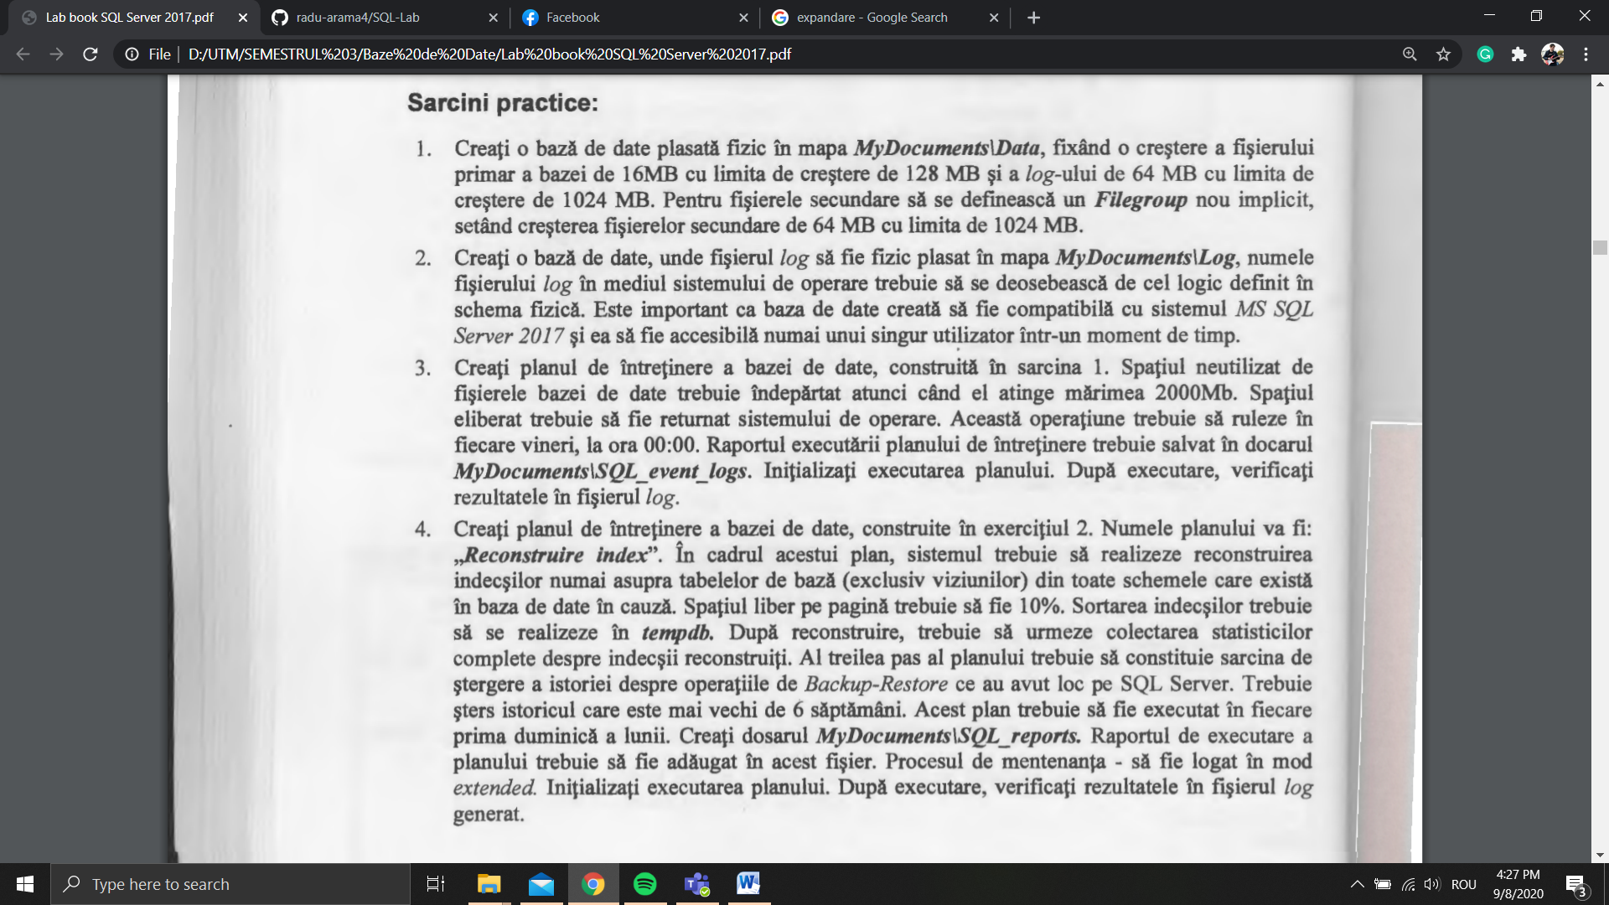

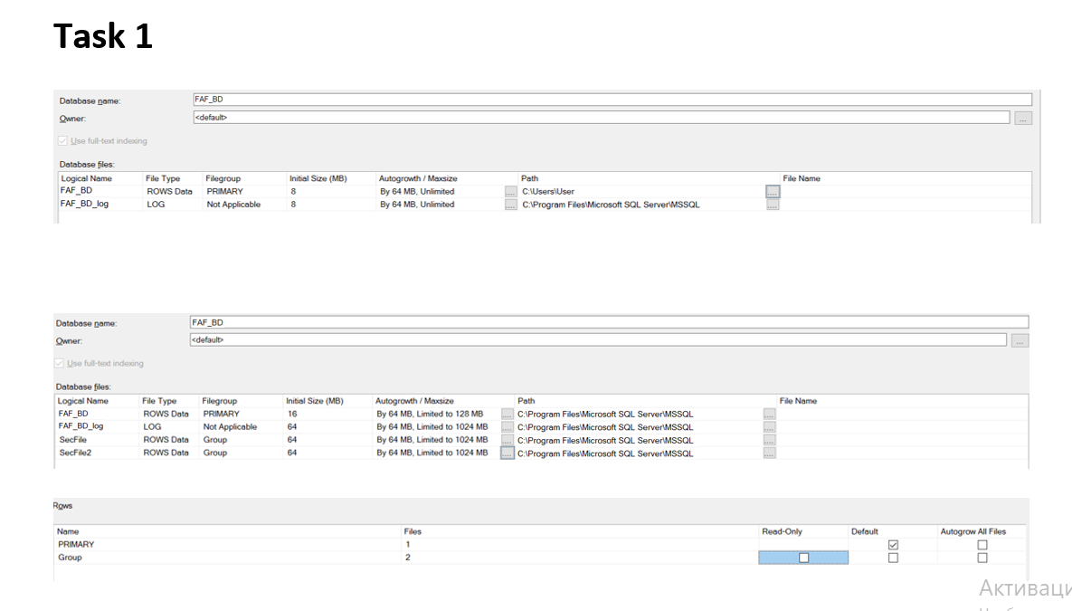

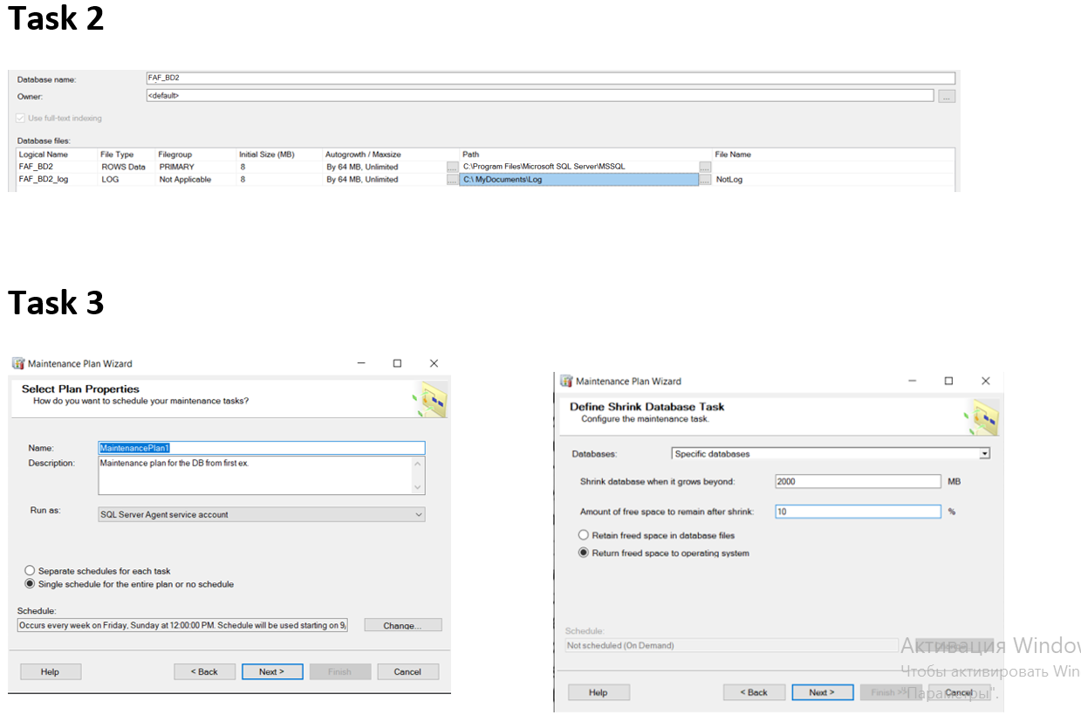

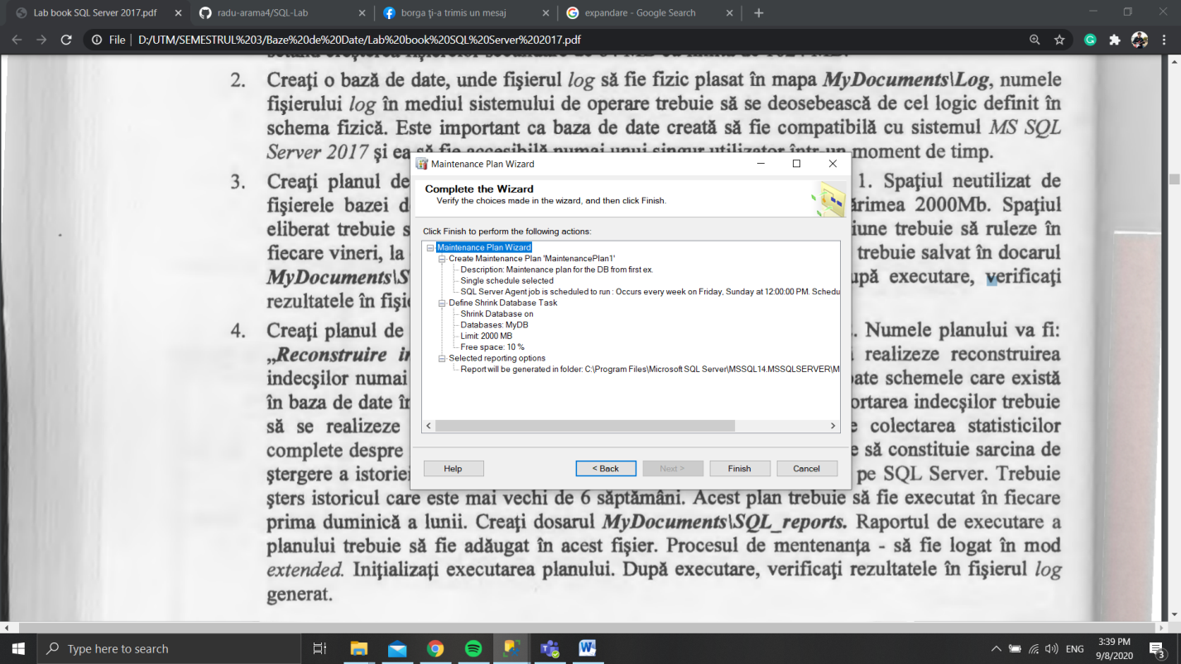

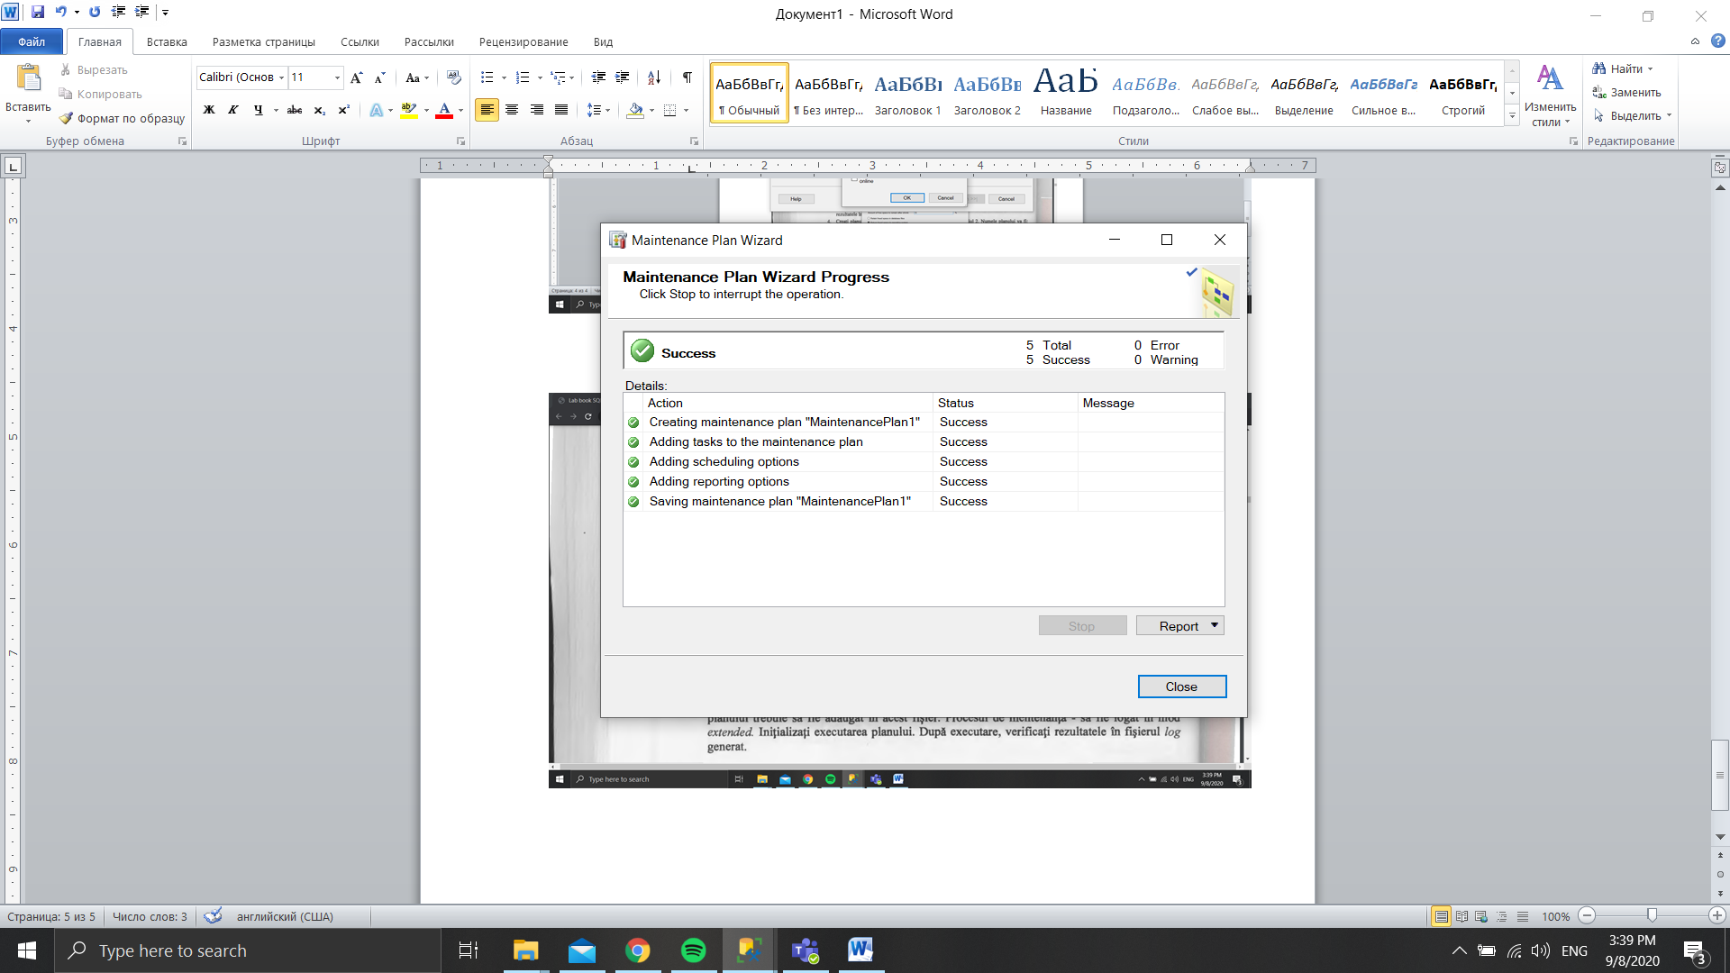

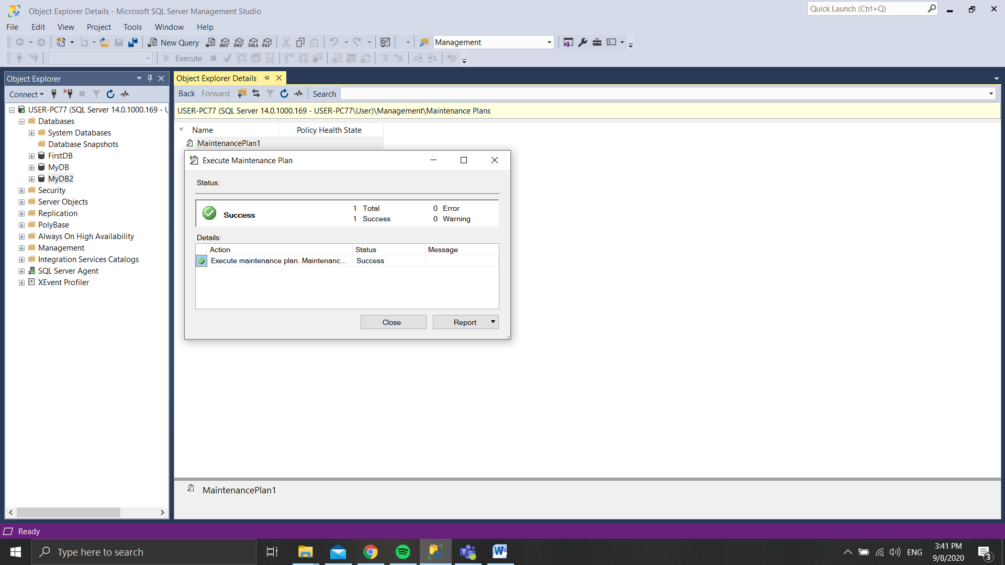

**Task - 4**

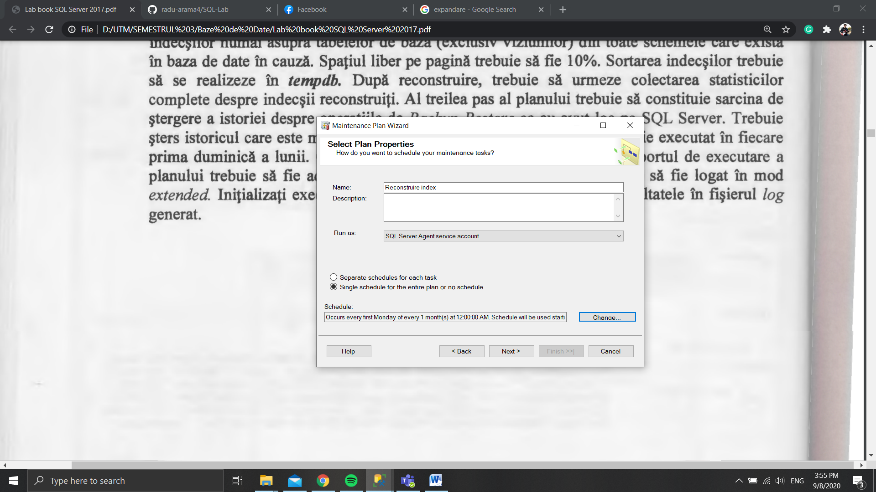

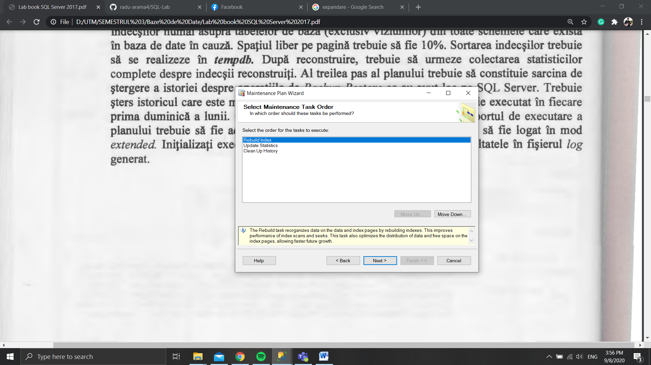

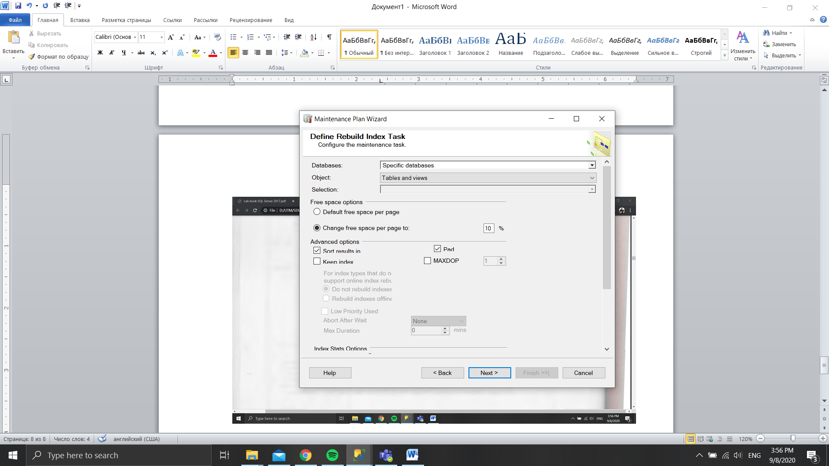

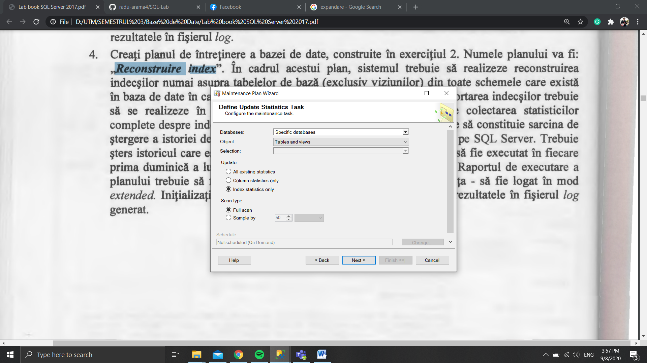

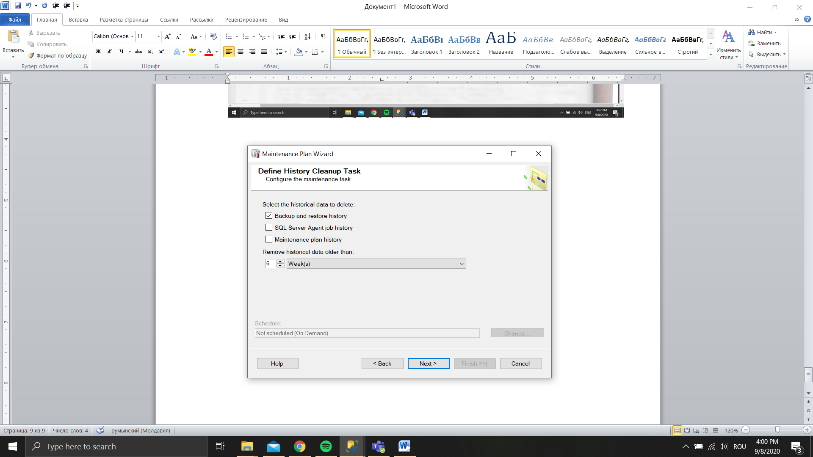

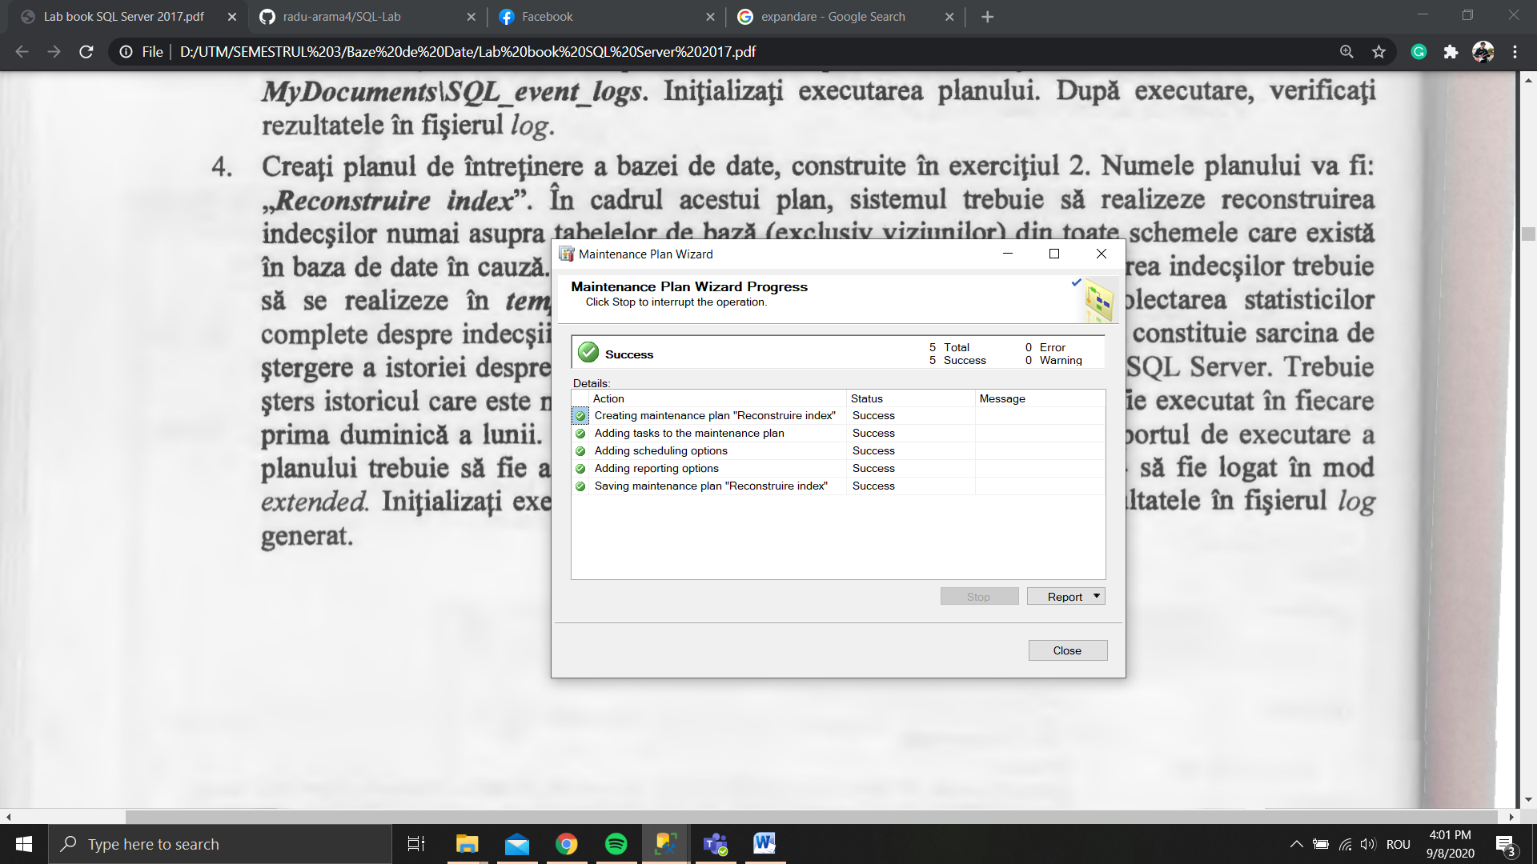

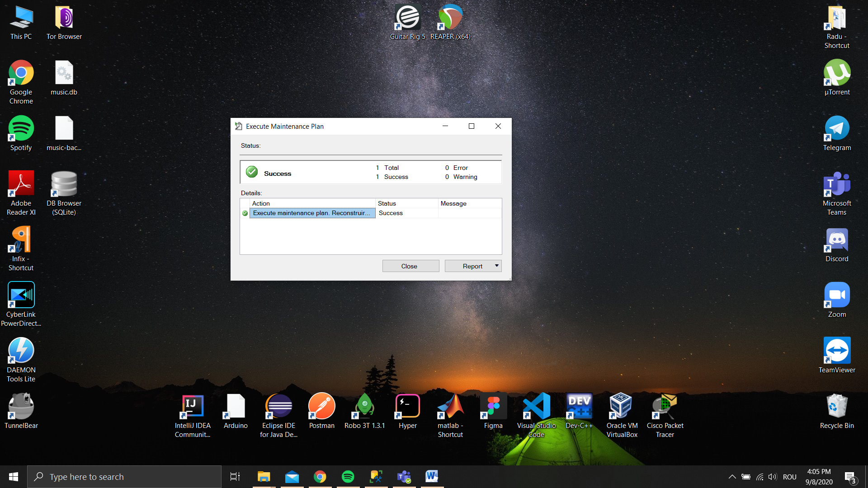

**Conclusion!!!**

BY doing all this tasks and answered all theoretical questions I understood how to create and maintain databases with using SQL SERVER 2017.It will help me in future to use SQL SERVER and create some new data bases by coding. Also it is very useful for working with big data , and doing data analyzing. I learned how to use Maintenance Plan Wizard with its help I can create and automatize databases.